# PREDICTION OF UNEMPLOYMENT IN INDIA USING FB PROPHET

**Dr. P. SELVARANI 1, T. PRAVEEN KUMAR2, R. SANTHOSH3, D. RAHUL RAJ4**

**Associate Professor1, UG Scholar 2,3,4**

# Department of Computer Science and Engineering

Vel Tech High Tech Dr. Rangarajan Dr. Sakunthala Engineering College.

# ABSTRACT

The unemployment rate is a key indicator of economic performance and financial market risk. The main causes of unemployment in India are Large population, lack of professional qualifications, or poorly educated workforce. Labor-intensive sectors have suffered from a slowdown in private investment, especially after the banknote withdrawal. The Covid surge has made unemployment one of the biggest problems in India. The purpose of this project is to predict the future unemployment rate in India using the FB Prophet model. This model is used to predict the future values and developed by Facebook. There are many predictive model in unemployment using LSTM and ARIMA model but the values are not much precise, so we proposed the FB Prophet model for predicting the precise value. We can get a precise with the help of FB Prophet Model. The values are predicted using the FB prophet model and the predicted values are displayed in the form of graph.

**Keywords**: Autoregressive Integrated Moving Average (ARIMA), Long Short Term Memory(LSTM), Facebook(FB) prophet, Unemployment.

**INTRODUCTION**

Unemployment is characterized as a phenomenon where labourer who are equipped for working and ready to work, don't look for some kind of employment. It is communicated as a proportion of the complete number of jobless people to the all out work power. The issue of joblessness has been developing since Independence,

and particularly so for the adolescent   
According to data provided by CMIE, India's unemployment rate amid lockdowns and travel restrictions is 12.81% as of 8 June 2021. Earlier, India's unemployment rate surged from 6.5% in March 2021 to 8% in

April 2021, reaching 14.7% at the end of May, while the employment rate fell from 37.6% in March to 8% in April 2021. rose to 36.8%.centerFor March it then rose to 9.1% in December 2020. While monitoring the Indian economy, the unemployment rate has dropped again from 9.1% in December 2020 to 6.5% in January 2021. In 2020, India's unemployment rate fell from a record high of 29% to 7% in September 2020 after the employment rate rose from 36.9% to 37.9% before the country went into lockdown. Lockdown to contain coronavirus outbreak forces many industries to Lockdowns, unemployment rises across the country.

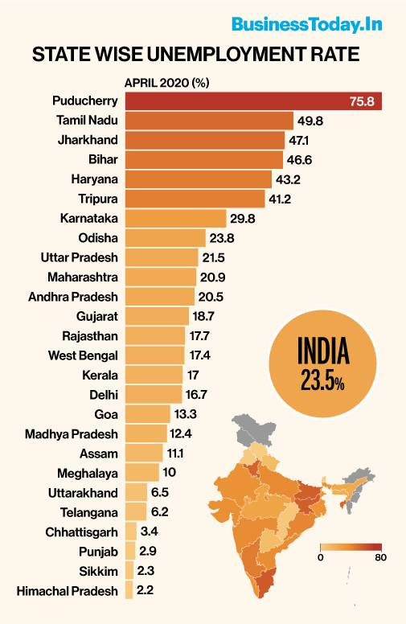



FIG 1.1 Unemployment Rate In India FIG 1.2Unemployment

|  |  |
| --- | --- |
| MONTH | UNEMPLOYMENT RATE |
| March | 6.5 |
| April | 8 |
| May | 14.7 |
| June | 12.8 |

**Table 1: UNEMPLOYMENT IN INDIA DURING 2021**

FIG 1.3 **UNEMPLOYMENT IN INDIA DURING 2021**

**RELATED WORKS**

**[1]Gogas, Periklis** et.al [2022] aims to directionally forecast the euro-area unemployment rate. Unemployment has a direct impact on public finances and yields serious sociopolitical implications. This study To the best of our knowledge, no other studies forecast the euro-area unemployment rate as a whole. The data set includes the unemployment rate and 36 explanatory variables, as suggested by theory and the relevant literature, spanning the period from 1998:4 to 2019:9 in monthly frequency

# [2]Desaling Germay et.al (2016) Unemployment is one of the several socio-economic problems exist in all countries of the world. It affects people's living standard and nations socio-economic status. The main objective of this study is modeling and forecasting unemployment rate in Sweden. The study exploits modeling unemployment rate using SARIMA, SETAR, and VAR time series models determine the goodness of fit as well as the validity of the assumptions and selecting an appropriate and more parsimonious model thereby proffer useful suggestions and recommendations.

# [3]Agrahari (2021) The current paper aims to analytically visualize the future outcomes that the post-pandemic India might have in store for its citizens. We use time series forecasting on various collected data and combined the statistics of economics-deciding parameters to forecast the trends that might be prevalent in the next year. Since, the data contains a single anomalous trend, even the Prophet model could not learn this property from the data since this trend is not seasonal in nature. The current study proposes a novel architecture to deal with these rare unusual trends by combining two models - one learning normal usual patterns and the other getting trained on usual as well as rare anomalous patterns. It could help in dealing with sudden hike patterns like due to COVID-19 in the data, and lead to better forecasting on future timeframes. We combined the results of two distinct time-forecasting models trained on two sets of data of varying timeline lengths, using parameters obtained from Least Squares Approximation (LSA). The LSA helps us find an approximate [vector approximation](https://www.sciencedirect.com/topics/computer-science/approximation-vector) so as to obtain a model performing closely to the actual.

# [4]Katris et.al (2020) are explored and analyzed time series and machine learning models for prediction of unemployment in several countries (Med, Baltic, Balkan, Nordic, Benelux) for different forecasting horizons. FARIMA is a suitable model when long memory exists in a time series and has been applied successfully for predicting unemployment. To overcome the potential issue of heteroskedasticity, we explore whether FARIMA models with GARCH errors achieve more accurate results.

# [5]Mezhoudi et.al ( 2021) Student employability is crucial for educational institutions as it is often used as a metric for their success. The job market landscape, however, more than ever dynamic, is evolving due to the globalization, automation, and recent advances in Artificial Intelligence. Identifying the significant factors affecting employability, as well as the requirements of the new job market can tremendously help all stakeholders. Knowing their weaknesses and strengths, students might better plan their career.

# [6]Wes Mc Kinney (2016)

# In this paper we will discuss pandas, a Python library of rich data structures and tools for working with structured data sets common to statistics, finance, social sciences, and many other fields. The library provides integrated, intuitive routines for performing common data manipulations and analysis on such data sets. It aims to be the foundational layer for the future of statistical computing in Python. It serves as a strong complement to the existing scientific Python stack while implementing and improving upon the kinds of data manipulation tools found in other statistical programming languages such as R Language.

# [7]Gupta (2020) COVID-19 is spreading really fast around the world. The current study describes the situation of the outbreak of this disease in India and predicts the number of cases expected to rise in India. The study also discusses the regional analysis of Indian states and presents the preparedness level of India in combating this outbreak. The study uses exploratory data analysis to report the current situation and uses time-series forecasting methods to predict the future trends.

# Problem Statement :

Unemployment is one of the biggest issue in all over the world. Due to this unemployment the mental stress for peoples are became so high. This unemployment rate is increasing day by day. So, many of the them started predicting the unemployment rate using the machine learning algorithms such as linear regression, LSTM, ARIMA and so on but those prediction modules were not much accurate and the time consumption is high to overcome these problems in the prediction module we use FB prophet

# EXISTINGSYSTEM:

Long short-term memory is an artificial recurrent neural network architecture used in the field of deep learning. Unlike standard feed forward neural networks, LSTM has feedback connections. It can process not only single data points, but also entire sequences of data.

# DISADVANTAGES:

# •LSTMs take longer to train.

# •LSTMs require more memory to train.

# •LSTMs are easy to over fit.

# •Dropout is much harder to implement in LSTMs.

# •LSTMs are sensitive to different random weight initializations.

# PROPOSED SYSTEM:

# Prophet is a time-series forecasting technique based on an additive model that fits non-linear trends with annual, weekly, and daily seasonality and holiday effects. It is best suited for time series with strong seasonal effects and historical data for multiple seasons. Prophet is tolerant of missing data and changing trends, and usually handles outliers gracefully. Prophet is open source software released by Facebook's Core Data Science team. Available for download on CRAN and PyPI

# ADVANTAGES:

• A major advantage of Facebook's Prophet is that it can be circumvented by anyone without prior experience or deep knowledge of time series modelingProphet is accurate and fast.

**ARCHITECTURE DIAGRAM:**

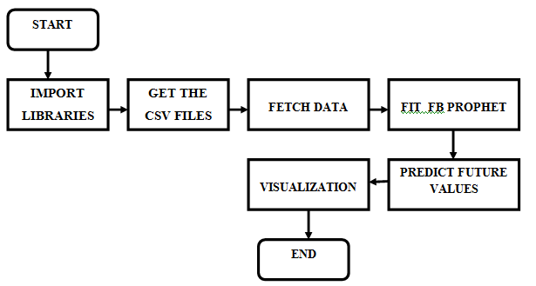

**FIG 1.4: ARCHITECTURE DIAGRAM**

The above architecture diagram describes the process that we follow to predict the future values using the FB Prophet forecasting model. The diagram describes about the process of getting the data source in the form of CSV file and it also says about model fitting and time series forecasting of the FB Prophet model.

**Steps to be followed :**

* + - The modules such a pandas FB prophet are installed
    - The modules are imported
    - The input CSV file is read
    - The datas are manipulated
    - The future value is predicted using FB prophet module
    - The values are represented in the form of graph using the Matplotlib keyword

**ALGORITHM :**

**STEP 1 :** Importing the Pandas, numpy, matplotlib Libraries Files.

**STEP 2:** Getting CSV File and Reading CSV file

**STEP 3:** Manipulate the data

**STEP 4:** Then fitting the FB prophet module to predict the future values

**STEP 5:** Then predicting the future values

**STEP 6:** Then visualizing the future values

**MODULES:**

* + - Import the Libraries
    - Getting The CSV File
    - Reading The CSV File
    - Manipulating the Data
    - Predicting Future Values

**Module 1: Importing the Library Files**

First We are importing the required library files such as ***numpy, pandas and prophet for*** Prediction Purpose and From ***matplotlib***  Importing pyplot for Visualization Purpose.

|  |
| --- |
| ***import numpy as np***  ***import pandas as pd***  ***import prophet***  ***from matplotlib import pyplot*** |

# Module 2: GETTING THE CSV FILE:

# Now we are getting the Dataset Containing the past values of the unemployment rate . To predict the future values

# 

# FIG 1.5: Unemployment Data set

# Now after downloading the data, it’s time to import the necessary Python libraries and the dataset. Before importing the libraries make sure that you have installed the FB prophet model. You can easily install it by using a pip command;

# Module 3 - READING THE CSV FILE:

# On google colab by using some certain python codes we are Importing the CSV file for our further need

***From google.colab import files***

***Uploaded = files.upload ()***

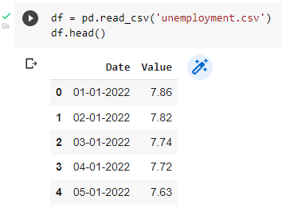

# Fig 1.6: Reading CSV file

# Module 4 - EDA Processing of Data set:

We are visualizing the data which we are used to predict the future values of the unemployment

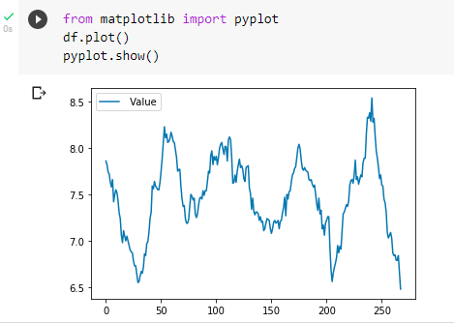

# Fig 1.7:Visuvalization of dataset

# Module 5 : MANUPULATE THE DATA:

Use a specific command to get the values ​​from the above file for predicting future values. The Facebook Prophet model only works with data where the column named 'ds' contains a string time series format and the column named 'y' contains continuous values. So you have to create your data accordingly.

Top of Form

Bottom of Form

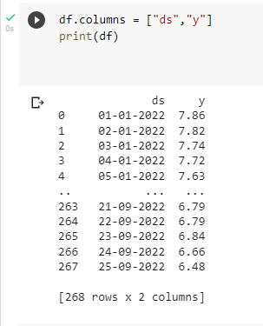

**Fig 1.8: Data Manipulation**

# Module 6 – Fitting the FB Prophet.

Now we are fitting the FB prophet Prediction module for the purpose of predicting the future values of unemployment. By using the following commands we are fitting the FB prophet module for prediction

***prophet = Prophet()***

***prophet.fit(df)***

# Module 7: Predicting The Future Values:

# Use the FB Prophet module to predict future values ​​and display the values ​​in a graph Chart values ​​change based on the data in the CSV

# 

# Fig 1.9:Predicted values

**EXPERIMENTAL RESULT:**

The predicted future values are now visualized in the form of graph

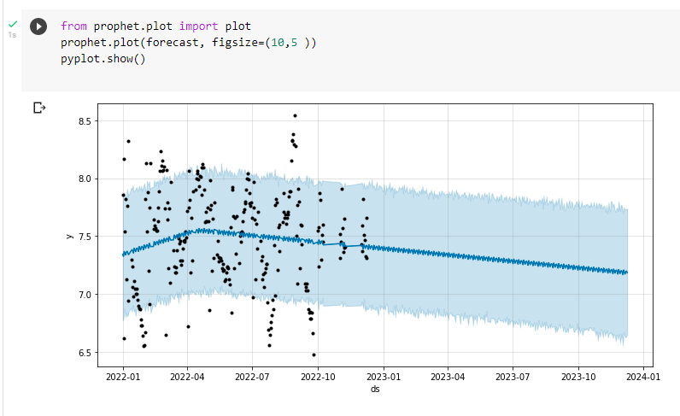

**FIG 2.0: RESULT**

The above diagram is an experimental result of our prediction module. This graph visualizes the predicted future values of the unemployment rate. The graph contains the date (ds) in the x axis and the unemployment rate (y) in the y axis.The predicted future values are forecasted above in the form of graph

# CONCLUSION

The goal here was simply to mess around with the Prophet package and I thought Unemployment would make an interesting data set. The blue fit is perhaps slightly under fitting but you can see that the uncertainty on the estimate remains fairly constant over time, even into the future. In general, it offers more scope for generalization but it may respond too slowly to trend changes. Hence I think it is unreliable. I would not expect the Rate to maintain that trend for long. The red fit on the other hand seems to overfit the data. It follows the historical Rate action tightly and responds quickly to trend changes, however the uncertainty really blows up into the future making this prediction unreliable too, although the red trend is somewhat more believable. Personally I do not feel that this kind of Rate prediction is particularly useful, but it will be interesting to follow this and see how the Facebook algorithms pan out..

**FUTURE ENHANCEMENT:**

This project on prediction of unemployment rate in India is very useful in the future because we predict the future values so one can easily estimate the future unemployment rate. The prediction gives an accurate future values the data set should be upgraded up to date to get precise value

**REFERENCES**

[1 Ferreira JA, Reitzle M, Lee B, Freitas RA, Santos ER, Alcoforado L, Vondracek FW [2015] The composition of unemployment, re-employment, and psychological well-being: A longitudinal study of the unemployed in Portugal. A professional behavioral journal. ;91:  
54-64. Doi: 10.1016/j.jvb.2015.09.004

[2] Gogas,Periklis, Theophilos Papadimitriou, and Emmanouil Sofianos.(2022) "Forecasting unemployment in the euro area with machine learning." Journal of Forecasting 41.3.

[3] Desalinated German melon. (2016).. "Modeling and forecasting the Swedish unemployment rate using various econometric indicators".

[4] Agrahari, Ashutosh, et al., "Predicting impact on post-pandemic unemployment rate in India by time-series forecasting and least-squares fitting". Pattern recognition characters 152 (2021)

[5] Catrice, Christos. "Predicting Unemployment Using Time Series and Machine Learning Techniques". Computational Economics 55.2 (2020).

[6]Mezhoudi, Nesrine, et al. "Employment Forecast: An overview of current approaches, research questions and applications. ”Journal of Ambient Intelligence and Humanized Computing (2021):1-17Top of Form

Bottom of Form

[7] pandas:Basic Python library for data analysis and statistics Wes McKinney

Top of Form

[8] Ramos, P., Santos, N. und Rebelo, R. (2015). 「Performance of State Space and ARIMA models for Consumer Retail Sales Forecasting」、Robotics and Computer-Integrated Manufacturing 34:  
151163。<https://doi.org/10.1016/j.rcim.2015.12.015>

[9] Emir Žunić, Kemal Korjenić, Kerim Hodžić, Dženana Đonko2 (2020) "Applying Facebook's Prophet algorithm for successful sales forecasting based on real-world data", International Journal of Computer Science & Information Technology (IJCSIT) Vol. . 12 , #2 , DOI:10.5121/Ijcsit.2020.12203April 2020

[10] Rajan Gupta and Saibal K Pal, Trend Analysis and Forecasting of COVID-19 Outbreaks in India, doi: https:  
//doi.org/10.1101/2020.03.26.20044511 MedRxiv (2020)